Part 1.

Pinging to Cisco

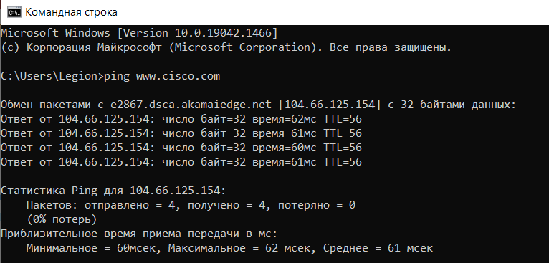

Checking Pinging to Afrinic(Africa)

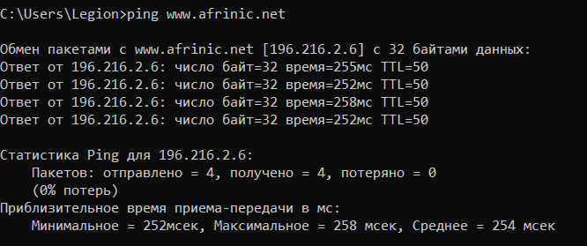

Checking Pinging to Apnic(Australia)

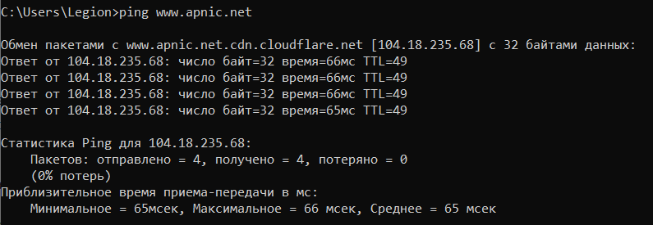

Checking Pinging to Lacnic(South America)

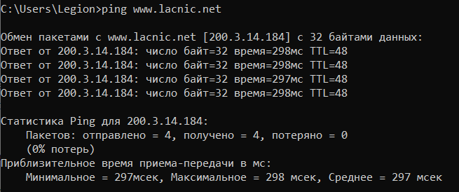

Checking Pinging to Arin(North America)

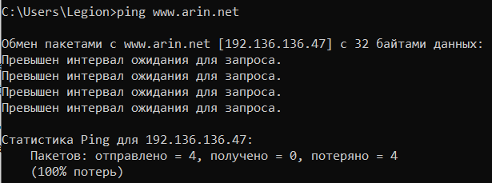

Part 2.

Tracerting with Cisco

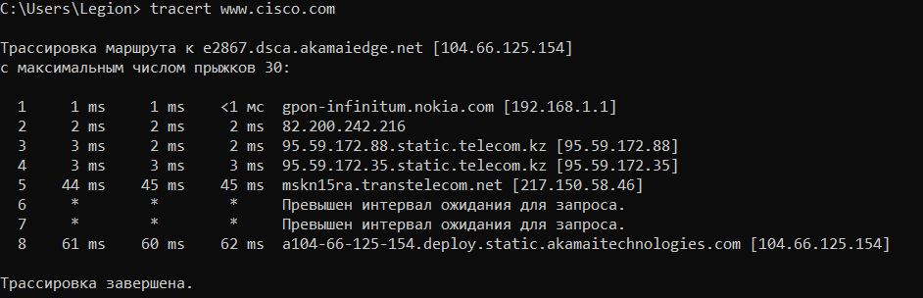

I chose afrinic website, so I will tracert with afrinic.net

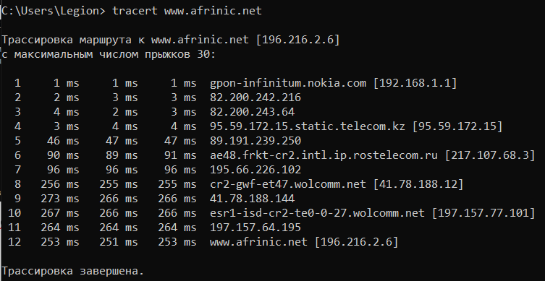

Whois result for hltv.org

